2025 Occultations by Special Main-Belt (MB) Asteroids

The map below, and the corresponding table on the next page, show the paths for occultations of a selection of important Main-Belt asteroids that will be occulted in 2025. On the map, some paths end with “A” (star Altitude becomes too low) and/or “S” (Sun or twilight too bright). Included are objects that have unusual shapes, or known or suspected significant moons, for which new observations will be valuable to better characterize them. Any future updates will probably not be given in this document, but will more likely be made to IOTA’s special main-belt asteroidal occultations page for 2025 at https://occultations.org/publications/rasc/2025/nam25MBspecialoccs.htm that is associated with this document. A good example of a successful campaign for an occultation by an unusual main-belt asteroid was the discovery and confirmation of the large moon of (4337) Arecibo by occultations in 2021 described at https://occultations.org/publications/rasc/2024/AreciboMoonAccount.pdf, adopted from an article that was published in the October 2021 issue of Stardust, publication of the National Capital Astronomers. We hope to have some further special-object successes in 2025, with the opportunities portrayed below, including the map and table given on pages 248 and 249 of the RASC Observer’s Handbook 2025. The (319) Leona occultation on April 18th was very successful, with 10 well-spaced chords.

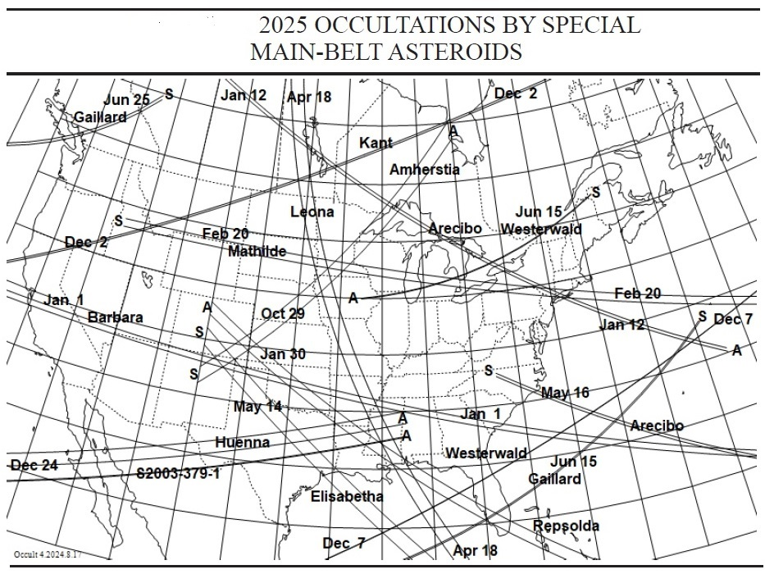

A table associated with the above map is at the top of the next page. The successive columns in the table list: (1) the date and central time of the event (the time at other locations along the path can be a few minutes different); (2) the number and name of the occulting asteroid; (3) the catalogue and number of the occulted star; (4) the star’s apparent visual magnitude; (5) the star’s J2000 right ascension and (6) declination; (7) the expected magnitude change from the combined brightness when (if) the star is occulted; if the mag. drop is noticeably less than predicted, it may show that the star is a previously unknown close binary; (8) the predicted maximum duration of the occultation in seconds; and, (9) the path location specified by the lands crossed by the ends of the path shown on the map. The two-letter abbreviations for the US States and Canadian Provinces are given, with the order indicating the direction of motion of the shadow. “Baja” is Baja California, either Norte or Sur, while “Mex” denotes the rest of Mexico. CU is Cuba and BS is Bahamas. Due to uncertainties mainly in the ephemerides of the minor planets from which these predictions are derived (most star positions are now accurately determined from the European Space Agency’s Gaia mission), the region of visibility of an occultation is uncertain, but now by only a few tenths of a path-width for most of these events. Errors remain, so those near but outside the paths should try to observe. It’s also useful, especially for the brighter stars that produce high signal-to-noise recordings, to observe even if you are located up to about 10 path-widths from the predicted path, to check for the possibility of an occultation by a possible satellite of the asteroid.

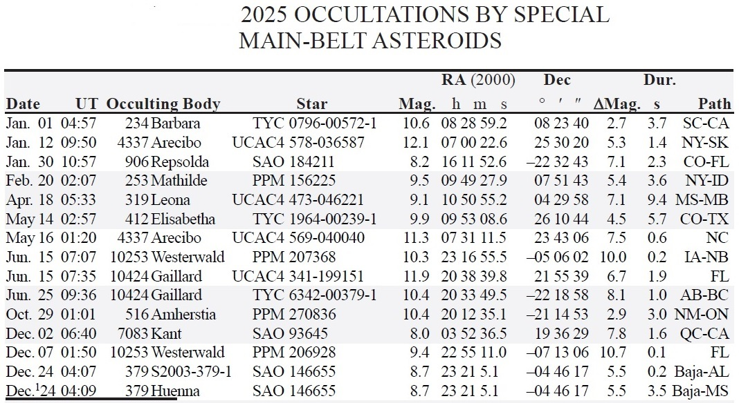

Paths are shown if occultations by any of the 72 originally selected (in Aug. 2024) special MB asteroids of stars brighter than magnitude 12.2 cross North America during 2025.

More Special MB Asteroids and Observing Strategies

For 2025, we selected the 72 asteroids described below for our special MB asteroids; in the descriptions on pages 8-12 below, an “-x” follows the object’s name, if an occultation by it of stars brighter than mag. 12.1 will occur in North America during 2025 and is shown on the RASC Handbook map and table (pages 248 & 249) and in the first map and table above (on p. 1 and 2). For those asteroids, occultations by fainter stars, yet observable by many, may occur, and relatively bright events will occur in other parts of the world. In the middle of 2025, 54 more asteroids have been added to our special list, including several discovered or suspected during occultations since the list of 72 was prepared in 2024. The new objects are described in red font in the descriptions below while green font shows some older objects, mainly from Dave Herald’s Occult4 satellite list; all others are in black font. The wide binary (617) Patroclus and its large moon Menoetius is important, but it’s a major Trojan object so it is not considered here; there are no observable occultations by it of stars brighter than mag. 14 visible from areas of North America with observers; the same is the case for (911) Agememnon that is another large Trojan with a small moon found from a 2012 MD video occ. obs. Pluto and other Kuiper Belt objects with moons are discussed in the Distant Objects section at the end of the 2025 RASC Handbook, pp. 250-251. However, this year, we don’t have separate Web pages for these other classes of occultations, but links to documents with maps and tables, and worldwide input files for them, are given on the page for all 2025 asteroidal occultations at https://occultations.org/publications/rasc/2025/nam25MBoccs.htm .

With now 126 special asteroids, the number is getting large. All of these should be tried from convenient home locations or observatories, if the predicted path is 5 path-widths or less of your location; for some objects where we are only interested in refining the shape, for “peanut-shaped” or contact binaries, like 319 Leona and 234 Barbara (and some others), you might try only if you are 1 path-width or less from the expected path. However, in my opinion, 51 of these objects (including Leona and Barbara) are “most special” (their asteroid # and name are underlined in the asteroid descriptions on pages 8-12 below), deserving multi-station expeditions with mobile telescopes, if the path is within reasonable travel range. These involve Main-Belt (MB) spacecraft targets, MB asteroids with moons determined from previous occultations to likely be orbiting within 10 moon diameters of the main object (such that they have a reasonable chance for detection with a several-station effort), including possible contact binaries indicated by well-spaced double occultations not involving double stars and not as likely to be just a graze on a large asteroid. Important objects like (319) Leona and (216) Kleopatra are included. Not included in the most special group are most of the Gaiamoon asteroids where the existence of a moon is only a possibility, and those with moons likely more than 10 moon-diameters from the main body where the chance for detection by a single observer is less than 10%; of course, those should be tried from fixed observatories when the occulted star is bright enough to get a good recording with a short event by a relatively small moon, but they are generally too risky for a mobile effort. I provide a separate Occult input file for these “most special” objects, since they deserve more effort than the more numerous special MB asteroids. Before giving details for all of the asteroids, we give some maps and tables about occultations by the expanded selection of objects for most of the second half of 2025.

Maps and tables of North American Events with the Expanded List of Special MB Asteroids

A table for these to mag. 11.0 is below, with a corresponding Occult map on the next page; a plain text file with more information (longer lines), including J2000 RA and Dec, is at
https://occultations.org/publications/rasc/2025/nam25restMBspecialAllmap.txt .

2025 U.T. Diameter Durn Star Mag-Drop Elon % Star d Rely Planet
m d h m km " sec/m mag V R * o Ill No. <1.4 No Name
Sep 21 9 42.2 14 0.007 0.65s 10.1 6.7 6.9 72 UCAC4 535-039262 s 1.00 699 Hela
Oct 4 11 9.6 5.3 0.003 0.42s 10.3 9.2 9.5 169 UCAC4 512-001764 s 0.95 127418 2002 NB19
Oct 25 6 18.2 7.0 0.006 0.56s 8.7 8.2 7.7 160 TYC 0062-00389-1 s 1.00 10518 1990 MC
Oct 29 1 1.3 66 0.037 3.0s 10.4 2.9 2.5 85 TYC 6327-00270-1 s 1.05 516 Amherstia
Nov 6 12 17.4 49 0.026 5.0s 10.6 5.2 5.1 105 TYC 1935-01070-1 s 1.15 1359 Prieska
Dec 1 7 10.8 41 0.034 5.6s 10.5 2.8 2.0 133 TYC 0190-00798-1 1.35 219 Thusnelda
Dec 2 6 33.7 13 0.014 1.58s 8.0 7.8 7.7 170 TYC 1257-00931-1 s 1.50 7083 Kant
Dec 3 0 40.6 199 0.163 9.9s 11.0 0.22 0.25 89 TYC 6400-00016-1 s 1.25 6 Hebe
Dec 7 1 51.9 2.20 0.001 0.15s 9.4 10.7 10.4 87 TYC 5241-00814-1 s 1.00 10253 Westerwald
Dec 15 2 56.4 7.0 0.005 1.75s 10.2 7.6 7.3 134 TYC 0049-00224-1 s 1.30 10518 1990 MC
Dec 17 11 5.9 46 0.020 1.76s 11.0 3.8 3.6 70 TYC 0299-00482-1 s 1.00 234 Barbara
Dec 24 4 6.3 6.0 0.003 0.24s 8.7 5.5 5.1 77 TYC 5247-00660-1 s 0.85 379 S2003-379-1
Dec 24 4 8.8 91 0.048 3.5s 8.7 5.5 5.1 77 TYC 5247-00660-1 s 0.85 379 Huenna
Dec 25 3 1.2 199 0.144 7.3s 9.4 0.8 0.9 77 TYC 6404-00499-1 s 0.85 6 Hebe

The Occult map for the above list is on the next page. A separate path is given for (379) S2003-379-1, the 6km satellite of (379) Huena; its location is quite uncertain, so all south of the wide Huena path for 2 path-widths are encouraged to try to observe; the satellite path is unlikely to pass north of the Huena path. The (7083) Kant event on Dec. 2 is good because the star is very bright, great for looking for its “Gaia” moon. The path is also on the main map above, on p. 1. However, the star’s RUWE is greater than 1.4, so the path may shift by more than a path-width; those that close should try.

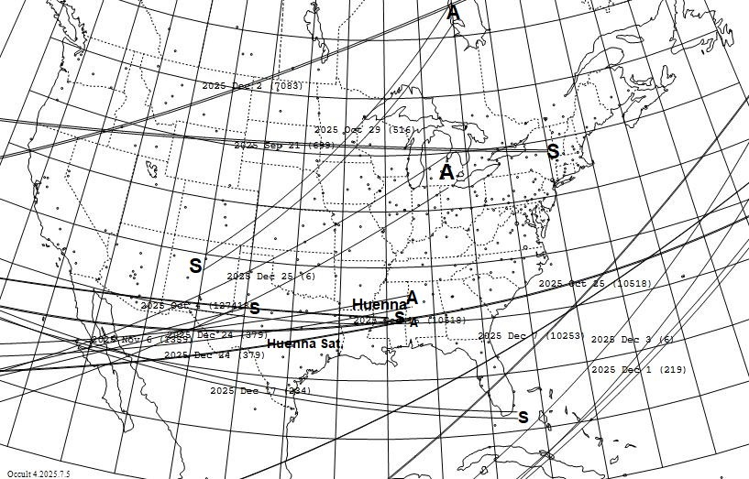

For clarity, I’ve added labels for the Dec. 24th occultation by Huenna and by its satellite; the other labels are all generated by Occult, giving just the U.T. date and the asteroid’s number in parentheses, given at the center of the plotted path.

At the top of the next page is a similar table for events using only the 51 most special asteroids for the rest of 2025 to mag. 12.2, followed by its Occult map. For this table, we’ve added the US State or Canadian Province 2-letter postal codes, and BS for Bahamas, at the ends of the path, with the order indicating the direction of motion of the shadow. The geocentric occultation UT date and time are given; remember that the local date may be in the evening a day earlier. For both tables, the UT times may be different from the geocentric time by several minutes, so it’s always best to get the time for your location or region from Occult Watcher (OW) or by clicking at your planned site on the zoomable map of the event’s OW cloud page. A plain text file with more information, including J2000 RA and Dec, is at
https://occultations.org/publications/rasc/2025/nam25restMBmostSpecialmap.txt .

We can show only some of the best events on the maps given on pages 1-5. But many of you have portable telescopes and cameras that can record occultations of 13th and even 14th magnitude stars. For even the most special occultations during the rest of 2025, there will be many more events observable from N. America, including 48 to mag. 13.0, 102 to 14.0, 237 to mag. 15.0, and 533 to mag. 16.0. So you should use Occult to generate your own local predictions with the Occult input files for these occultations that we provide at https://occultations.org/publications/rasc/2025/nam25MBspecialoccs.htm .
2025 U.T. Path Diameter Durn Star Mag-Drop Elon Star RUWE Planet
m d h m km " sec/m mag V R * o No. <1.4 No Name
Jul 30 7 33.5 Baja-ON 50 0.033 3.3s 12.1 3.2 3.1 99 UCAC4 556-002712 398 Admete
Sep 17 7 54.0 Mex-FL 3.0 0.002 0.20s 11.4 7.8 7.1 97 TYC 1286-01947-1 1.25 87464 2000 QV129
Sep 24 7 53.5 Mex-Baja 44 0.042 6.1s 11.6 2.7 2.6 138 UCAC4 624-005212 1.20 623 Chimaera
Sep 30 2 36.6 NV-ON 3.9 0.003 0.21s 11.7 7.1 7.0 89 UCAC4 355-139710 0.75 21814 Shanawolff
Oct 4 11 9.6 MS-Baja 5.3 0.003 0.42s 10.3 9.2 9.5 169 UCAC4 512-001764 0.95 127418 2002 NB19
Oct 8 8 53.1 Baja-FL 41 0.026 2.3s 11.8 2.2 1.4 87 TYC 0770-01637-1 0.95 219 Thusnelda
Oct 17 6 34.7 MB-NL 41 0.027 2.8s 12.1 1.9 1.3 93 TYC 0767-01174-1 0.85 219 Thusnelda
Nov 9 3 37.6 SC-Mex 3.0 0.003 0.80s 12.1 6.1 5.6 142 UCAC4 533-015463 1.45 87464 2000 QV129
Nov 18 22 46.6 MD-NJ 5.2 0.002 0.18s 12.2 8.7 8.5 64 UCAC4 381-159331 0.90 61784 2000 QL178
Dec 1 7 10.8 BS-Cuba 41 0.034 5.6s 10.5 2.8 2.0 133 TYC 0190-00798-1 1.35 219 Thusnelda
Dec 7 1 51.9 Mex-FL 2.2 0.001 0.15s 9.4 10.7 10.4 87 TYC 5241-00814-1 1.00 10253 Westerwald
Dec 17 11 5.9 Baja-FL 46 0.020 1.76s 11.0 3.8 3.6 70 TYC 0299-00482-1 1.00 234 Barbara
Dec 27 1 23.7 Mex-FL 5.2 0.003 0.18s 11.2 8.3 8.0 68 TYC 5823-00238-1 0.95 13294 Rockox

Occult map showing the paths of events by the most special MB objects for the rest of 2025 to mag. 12.2.
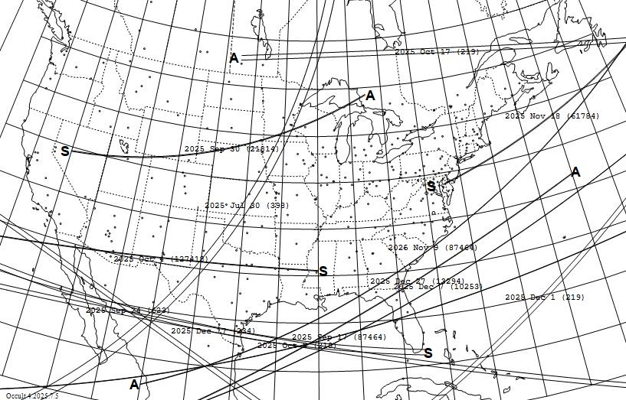

The path for the Oct. 8th occultation misses the Florida peninsula, but passes over Key West, FL.

As an example, we’ve generated a map and associated table for occultations by the most special objects visible from much of the western USA (the specific search, that found 9 events, found occultations within 500 km of Stockton, Calif.) to mag. 14.5 for the rest of 2025, given on the next page. You can open our file with the asteroid predictions module of Occult4, selecting “List & Display occultations” and open the worldwide file, such as 2025restMBmostSpecial.xml (which we’ve used for below; for more events, especially for fixed observatories, you can use the “MBallSpecial” file). The map includes the names of the cities from our slightly modified North American .site file since they are legible on this regional map. On the continent-wide maps above, dots are plotted for the cities, but their names were not plotted, for legibility. I have annotated the regional map below, to add “A” and “S” at the ends of some paths, and give at least the 2025 date in font larger than the Occult event labels, to improve legibility. The Dec. 6 Psyche occultation will not be observable due to the very small magnitude drop, while the two Sept. events will be difficult, needing good conditions and large scopes for useable results; they will be more suitable for observatories within the wide paths. Some of the paths pass near or over RECON stations, so I hope they might be alerted.

w. USA map showing the paths of events by the most special MB objects for the rest of 2025 to mag. 14.5

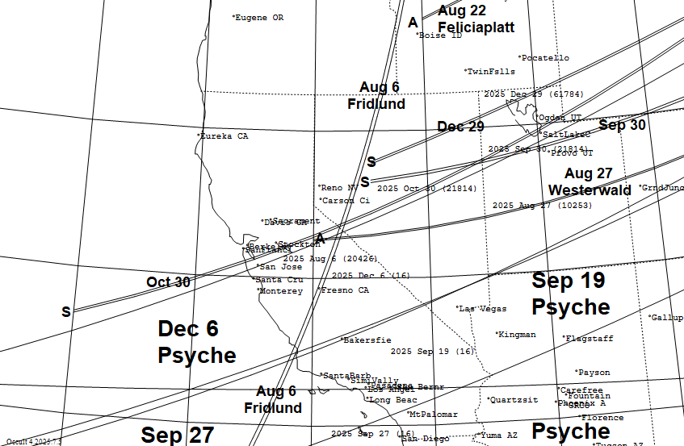

A table for the above map is below, as a picture file, without star coordinates. Low altitude or twilight will hinder some events, as shown by the star and Sun alt. A plain text file including the coordinates is at https://occultations.org/publications/rasc/2025/CalifRest2025MBmostSpecialToMag14p5.txt .

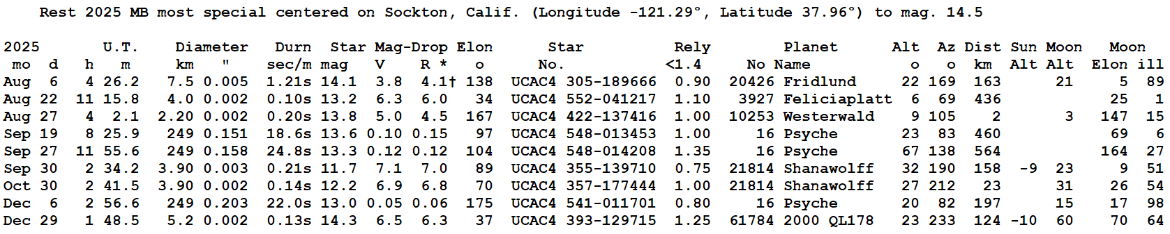

The above map and table will be most useful for mobile observers. But those with large fixed-site telescopes might observe other occultations from the full list of special MB asteroids, if the paths pass close enough to provide some chance for an occultation by a possible (or known from previous events) satellite of the asteroid. If you are within 5 (main object) path-widths of the central line, you might have an occultation; you can get some guidance of a practical distance from the asteroid descriptions in the next section. A calculation for the rest of 2025 for all 126 of our special MB asteroids where Stockton, Calif. was either within the predicted path, or less than 10 km from one of the limits, including all of the events in our file to mag. 16.0, found 12 unique occultations that are in
https://occultations.org/publications/rasc/2025/StocktonRest2025MBspecialAll.txt .
Kevin Green in Connecticut is interested in mobile efforts to observe occultations by (20426) Fridlund; he gives information about upcoming opportunities in a message to IOTAoccultations that you can read at https://occultations.org/publications/rasc/2025/(20426)FridlundAndGreenPlans2025July.pdf .
Finding occultations by individual objects: You can do this by checking the “asteroid number” box (and enter the asteroid’s # to its right) in the upper right (orange area) part of the Selection Filters page when you open our Occult input file with the program. For example, Teddy Oakey at the Univ. of Virginia is interested in occultations by the planned spacecraft target (59980) 1999 SG6, as he described in two messages to IOTAoccultations at https://occultations.org/publications/rasc/2025/20250720-21(59980)1999SG6eventsOakeyCall.pdf and at https://occultations.org/publications/rasc/2025/OakeyMsg20250726.pdf. Although the July events he discussed are past (OW shows that the July 20th event was recorded from 6 stations, with 3 positives, 2 misses, and 1 “observed, report to follow”; unfortunately, it looks like the July 22nd event in Australia was clouded out), there are more, see the unannotated map below showing the paths of occultations by the object during the 2nd half of 2025; unfortunately, most are too faint for mobile efforts, but as Oakey says in his recent message, they are interested in help for trying the Aug. 19th event with 11in or larger scopes:

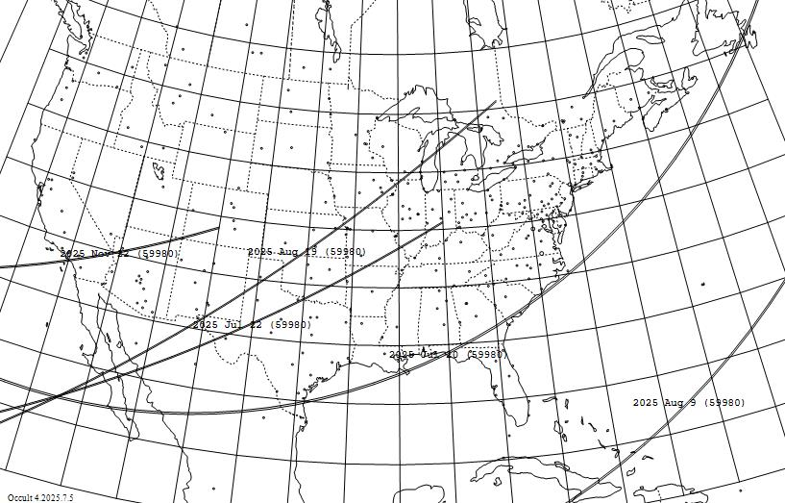

Event Summary for North American occultations by 8km (59980) 1999 SG6 during the 2nd half of 2025, to mag. 16

2025 U.T. Diam. Durn Star Mag-Drop Elon Star RUWE Moon R.A. (J2000) Dec.
m d h m " mag V R o No. <1.4 Dist ill h m s o ' "
Jul 20 3 57.5 0.005 0.61s 13.8 4.1 3.9 171 UCAC4 384-148925 1.00 112 26 20 16 49.103 -13 13 52.44
Jul 22 9 16.4 0.005 0.60s 15.9 2.2 1.9 173 UCAC4 383-155915 0.95 144 8 20 15 6.691 -13 25 51.02
Aug 9 1 52.2 0.005 0.64s 15.8 2.4 2.1 162 UCAC4 375-172994 0.95 16 100 20 1 53.647 -15 6 16.67
Aug 19 6 54.8 0.005 0.76s 14.2 4.1 3.7 151 UCAC4 370-177748 0.95 157 18 19 55 34.752 -16 3 11.52
Aug 20 4 36.9 0.005 0.78s 14.8 3.5 3.4 150 UCAC4 370-177682 1.00 168 11 19 55 6.090 -16 8 2.92
Oct 3 1 32.3 0.004 0.94s 15.8 3.3 3.0 107 UCAC4 356-191323 0.95 20 79 19 52 27.711 -18 54 43.42
Nov 22 3 29.3 0.003 0.28s 15.8 3.6 3.4 66 UCAC4 356-195728 0.95 46 3 20 34 11.555 -18 49 36.92

Sometimes of interest are occultations by a small group of asteroids, such as all 7 targets of the Emirates MBR mission, which are minor planet numbers 269, 623, 10253, 13294, 23871, 59980, and 88055. Unfortunately, the Occult4 selection menu only lets you specify one object at a time. However, it is possible to do the search for occultations with a User Minor Planet (orbital) Elements file that includes just these 7 objects, and opening the resulting file lists the occultations by all of them. We have done this to create the map and associated table at the top of the next page. The search for 2025 July 19-Dec. 31 found 429 events worldwide of stars to mag. 16 and solar elongation greater than 15 deg.; 38 of them occur over or near North America. The 10 of those of stars of mag. 14 and brighter are mapped and tabulated below. Those outside N. America should alert us to good occultations by any of these objects that occur in safe areas of your country that might benefit from outside help for a multi-station effort, like the one to S. Africa that Teddy Oakey described in his first message above.

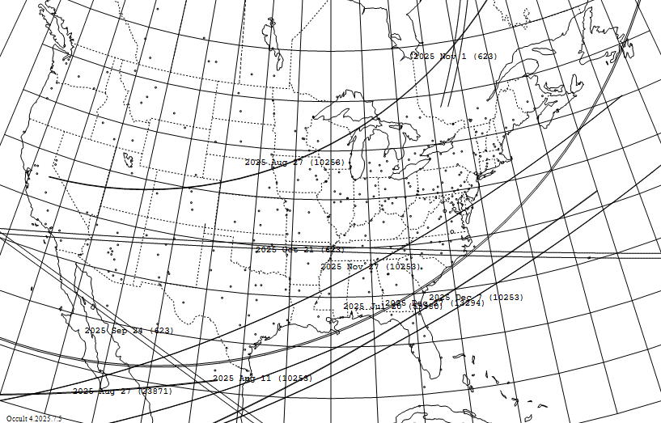

North American Occultations by UAE-MBR targets to Mag. 14 for 2025 July 20 - Dec. 31
2025 U.T. Diameter Durn Star Mag-Drop Elon Star RUWE Planet Moon
m d h m km " sec/m mag V R * o No. <1.4 No Name Dist ill
Jul 20 3 57.5 8.0 0.005 0.61s 13.8 4.1 3.9 171 UCAC4 384-148925 1.00 59980 1999 SG6 112 26
Aug 11 10 9.5 2.20 0.002 0.29s 12.8 6.3 5.9 149 UCAC4 428-125644 1.00 10253 Westerwald 4 95
Aug 27 3 55.1 2.20 0.002 0.20s 13.8 4.9 4.5 167 UCAC4 422-137416 1.00 10253 Westerwald 147 15
Aug 27 11 28.2 6.3 0.002 0.18s 14.0 6.8 6.5 45 UCAC4 544-040757 1.00 23871 1998 RC76 93 17
Sep 24 7 53.3 44 0.042 6.1s 11.6 2.7 2.6 139 UCAC4 624-005212 1.20 623 Chimaera 160 6
Oct 21 7 23.6 44 0.046 4.7s 13.9 0.7 0.5 155 UCAC4 626-004193 1.10 623 Chimaera 158 0
Nov 1 22 55.4 44 0.046 4.9s 12.7 1.5 1.3 153 UCAC4 621-003356 1.00 623 Chimaera 45 82
Nov 27 2 33.5 2.20 0.001 0.16s 12.8 7.2 6.7 95 UCAC4 410-143427 2.65 10253 Westerwald 19 38
Dec 7 1 51.9 2.20 0.001 0.15s 9.4 10.7 10.4 87 TYC 5241-00814-1 1.00 10253 Westerwald 108 98
Dec 27 1 23.7 5.2 0.003 0.18s 11.2 8.3 8.0 68 TYC 5823-00238-1 0.95 13294 Rockox 4 31

Note that the bright (mag. 9.4) Dec. 7th occultation by Westerwald is on our RASC-published map and associated table (and p. 1 and 2 of this document); in the US, it will be visible only from Florida, from just north of The Villages and Ormond Beach.

Information about all 126 Special MB Asteroids, with the Most Special ones Underlined

In the descriptions below, the dimensions and separations given are in the plane of the sky at the asteroid; those will often project to greater distances on the ground.

(6) Hebe: Main 193km, moon ∼20km ∼900km away from 1977Mar5 vis. P. Maley; ON Vol. 1, p. 115; since chances for catching this are low, we recommend monitoring only stars that are brighter than Hebe.
(16) Psyche: The largest M-class (metallic) asteroid and target of a NASA mission now enroute to Psyche.
Again, we recommend concentrating efforts mainly on stars brighter than Psyche, where more stations can be deployed with small telescopes. Psyche’s shape is well-known from VLT observations and 3 past occultations that had 10 or more well-spaced chords; similar dense observations are needed to improve our knowledge of Psyche, not more single-chord observations of faint stars.
(22) Kalliope: Main 166km, 28km moon Linus 1100km away; Linus has orbit from Keck obs. & sep. pred.
(31) Euphrosyne: This 268km object has a 4 km moon 672 km away with orbit from VLT obs in 2019.
(53) Kalypso: is the lowest-numbered GAIAMOONS asteroid and is 115 km across.
(87) Sylvia: Main ∼250km, 10km moon Remus 694km away & 23km Romulus 1340km away; Keck obs.
(90) Antiope: This is a binary asteroid with equal large (~90km) components 171 km apart. Special procedures given at http://iota.jhuapl.edu/PlottingPathsForAntiopeOccultations.pdf are needed to show paths of occultations by the separate components, which is crucial for these events; often only a miss by both components will occur at the central line of an uncorrected prediction.
(93) Minera: Main ∼150km, 4km moon Aegis 630km away & 3km Gorgoneion 380km away; Keck obs.
(96) Aegle: Main ∼170km moon 43km ∼450km away from a 2002Aug10 NZ occ with 40cm scope.
(98) Ianthe: Main 105km moon 5km 2340km away from a 2004May16 vid. Occ.; see ON Vol. 11, #2, p8.
(121) Hermione: has an 8-km moon 770 km away, discovered by adaptive optics.
(146) Lucina: Main 132km, moon 6km 1600 km away, 1982Apr18 video obs., see Icarus Vol. 61, p. 224.
(165) Loreley: Main 180km; may have an ∼10km moon ∼200 km away, from a 2020Jul21 occ’n; see
https://www.asteroidoccultation.com/observations/Results/Reviewed/Data2020/20200721_165_Loreley_PROFILE.gif.
(203) Pompeja: is a GAIAMOONS 125km red asteroid that may be a captured TNO, like (269) Justitia.
(216) Kleopatra: This is the “Dog-bone” asteroid, the 2nd-largest M-class (metallic) asteroid, and has two small moons. Separate predictions are given for the paths of the larger one, Alexhelios.
(217) Eudora: is a GAIAMOONS asteroid about 67 km in diameter.
(219) Thusnelda: On 2007Dec18, D. Dunham recorded 2 occ’ns by this in FL, showing a peanut-shaped asteroid or possibly a contact binary; see https://www.asteroidoccultation.com/observations/Results/Reviewed/Data2007/20071218_219_Profile.png .
(234) Barbara-x: This may be a contact binary; past occultation observations reveal two lobes; see https://www.asteroidoccultation.com/observations/Results/Reviewed/Data2009/2009Nov21_BarbaraDec09UpdateChords.jpg.
(238) Hypatia: is a GAIAMOONS asteroid about 146 km in diameter.
(247) Eukrate: is a GAIAMOONS asteroid 140 km across from a 5-chord occ’n on 2018May12.
(252) Clementina: Probable unusual shape; see JOA 2023_1, p. 9.
(253) Mathilde-x: NEAR imaged half the asteroid in 1997; occultations could probe the other half. As far as we know, the Feb. 20th occultation was not observed and nobody signed up with OW to try it.
(264) Libussa: is a Gaiamoons asteroid.
(269) Justitia-x: This very red object may have originated in the Kuiper belt. It is a target of the UAE’s Main Belt asteroids mission planned to launch in 2028 and will orbit Justitia and land on it in 2034.
(276) Adelheid-x: Main ∼125km, 8km moon ∼500km away, 2022Aug31 K. Green occ’n; see
https://www.asteroidoccultation.com/observations/Results/Reviewed/Data2022/20220831_276_Adelheid_Profile.GIF.
(317) Roxane: This 19km object has a 5km moon, Olympias, with sep. 245 km, found by Gemini North.
(319) Leona-x: We want to improve knowledge of the size and shape of this object, to better analyze observations of the 2023 Dec. 12th occultation of Betelgeuse by Leona. The April occultation was well-observed from 10 well-spaced stations, mainly in MO; R. Venable ran 5 of them, on the east side.
(379) Huena-x: An 8-km moon 3000 km (33 diams) away discovered with adaptive optics at Keck in 2003.
(398) Admete: During a 2022Jan1 event, Miyoshi Ida had 2 occ’ns, perhaps by a contact binary.
(412) Elisabetha-x: May have a 4km moon 3 diameters away, based on a 2016 Mar. 17 event in Slovakia; see https://euraster.ericfrappa.com/results/2016/20160317-Elisabetha_crd.gif .
(449) Hamburga: may have a 9 – 62km moon up to about 220 km away -R. Lallemand GAIAMOONS.
(476) Hedwig: may have a 10 – 50km moon up to about 60 km away – GAIAMOONS 24Mar8
(504) Cora: is an approximately 30km GAIAMOONS metallic (class M) asteroid.
(513) Centesima: This asteroid has an unusual shape from a 4-chords occ’n on 2020Dec20 in the swUSA: https://www.asteroidoccultation.com/observations/Results/Reviewed/Data2020/20201220_513_Centesima_Profile.GIF . The “discordant” R of Station 5 was closely checked and is real.
(516) Amherstia-x: is a 73-km GAIAMOONS asteroid.
(532) Herculina: In 1978 June 7, a 45km satellite was claimed from observations of an occultation of a 6.2-mag. star; see E. Bowell et al., Bull. Amer. Astron. Soc. Vol. 10, p. 594 and Occ’n Newslet. Vol. 1, p. 152. HST and AO observations failed to confirm the moon, but now GAIAMOONS claims there might be a moon.
(542) Susanna: is a 2-km GAIAMOONS asteroid.
(550) Senta: A possible binary, according to GAIAMOONS, 24Mar20
(578) Happelia: Main 69km, 3km moon? 50km from center, from a 2017Feb24 occ’n in TX; see https://www.asteroidoccultation.com/observations/Results/Reviewed/Data2017/20170224_HappeliaProfile_Damit660_Satellite.gif .
(595) Polyxena: main ∼110km moon23km ∼270 away from a 2008Feb03 occ’n in Europe; see
https://euraster.ericfrappa.com/results/2008/index.html#0203-595 .
(605) Juvisia: is a 63km GAIAMOONS asteroid that may have a 10km moon up to 115 km away.
(623) Chimaera: This is a 44km 2nd flyby target of the UAE Main-Belt asteroids mission.
(699) Hela: is a GAIAMOONS and a Mars-crossing asteroid.
(702) Alauda: Main ∼190km, 4km moon Pichi unem 1226km away; orbit from VLT obs.with sep. pred.
(705) Erminia-x: May have an 8km moon about 400 km away, from a 2014 Dec. 8th occultation; see https://www.occultations.org.nz/planet/2014/results/20141208_705_Erminia_4UC_315_245088_Rep.htm .
(810) Atossa is a GAIAMOONS asteroid.
(879) Ricarda: is a GAIAMOONS asteroid.
(885) Ulrike: Possible contact binary from a 2020Jul12 European occultation; see https://euraster.ericfrappa.com/results/2020/index.html#0712-885 .
(906) Repsolda-x: main 70km, possible 10km moon ∼240km away, according to a 2023 Jan. 25 event in Calif.; see https://www.dr-ricknolthenius.com/events/20230124Repsolda/index.html .
(950) Ahrensa: is a GAIAMOONS asteroid.
(957) Camelia: This asteroid has an unusual shape; see https://www.asteroidoccultation.com/observations/Results/Reviewed/Data2021/20210915_957_Camelia_Profile.GIF .
(1016) Anitra: May have a 4-km moon, based on rotational light-curve observations.
(1024) Hale: is a GAIAMOONS asteroid.
(1089) Tama: Light-curves show 11km and 7km objects 21km apart, IAUC 8265 (2004) https://ui.adsabs.harvard.edu/abs/2004IAUC.8265....2B/abstract
(1127) Mimi: is a 47km GAIAMOONS asteroid.
(1139) Atami: 8 km eclipsing binary, moon 5 km up to 15 km away.
(1180) Rita: Suspicious 2-occ’n event observed 2024 Mar 4 from s. France; the star may be double.
(1237) Genevieve: 40 km GAIAMOONS object, moon 4-40 km, distance maybe around 200 km
(1359) Prieska: is a 50km GAIAMOONS asteroid.
(1423) Jose: is likely peanut-shaped from a 2025May05 occ by Nolthenius and Bender in Calif., see
https://www.dr-ricknolthenius.com/events/20250505-Jose/index.html
(1509) Esclangona: is a 7-10km object with a 4km moon, S/2003 (1509) 1 140km away, discovered by ESO/s VLT in Chile; it is also an uncharacterized GAIAMOONS asteroid (maybe a closer moon)?.
(1626) Sadeya: Main is 12km, moon 4km about 54 km apart, from light curve obs.
(1721) Wells: A double occ’n recorded at one station during a 2022Jan15 occ’n shows a peanut-shaped or maybe a contact binary; see https://www.asteroidoccultation.com/observations/Results/Reviewed/Data2022/20220115_1721_Wells_profile.gif .
(1800) Aguilar: is a GAIAMOONS asteroid.
(2219) Mannucci: is a 39km GAIAMOONS asteroid.
(2258) Viipuri: Main is ∼26km, moon 4km ∼130km away from a 2013Aug3 1frame maybe occ’n; see
https://www.asteroidoccultation.com/observations/Results/Reviewed/Data2013/20130803_ViipuriProfile.gif possibly confirmed by 2018Sep19 occ; see https://euraster.ericfrappa.com/results/2018/index.html#0919-2258 .
(2470) Agematsu: is an 11km object with a 2.6km moon at least 26 km away, from a 2024Aug8 occ’n.
(2494) Inge: Main is ∼47km, moon 8km ∼55km away from a 2016Nov11 occ’n; maybe just elongated; see https://euraster.ericfrappa.com/results/2016/index.html#1107-2494 .
(3457) Arnenordheim: is a GAIAMOONS asteroid.
(3800) Karayusuuf: 1.9 km GAIAMOONS object, moon 0.4-0.6 km, up to 11 km from center.
(3927) Feliciaplatt: main is 4km with 1.5km moon 11 km away, from a 2025Jan1 occ’n by Getrost in GA.
(4337) Arecibo-x: Binarity discovered during 2021 May occultation by P. Nosworthy and D. Gault in NSW, and confirmed a month later by R. Nolthenius & K. Bender in Calif., and shown by Gaia to have a 1.3d period. The diameters are 19km (main) and 12km (moon) in orbit with mean distance 50km; more in A&A 674, A12 (2023) available at https://doi.org/10.1051/0004-6361/202243796 .
(4552) Nabelek: This was thought to be 6 km across, but a recent paper argues that it is about 20 km.
(5044) Shestaka: 6.4 km GAIAMMOONS object, moon 2-5 km up to 30 km away.
(5232) Jordaens: Simpson, Yeung, & Schmidt, Alberta occ 2024Feb1 main 12km moon 8km 33 km apart; for more, see https://www.asteroidoccultation.com/observations/Results/Reviewed/Data2024/Final-5232_Jordaens.2400x2400-ed1.jpg .
(5457) Queen’s-x: Main 21km, 2km moon 20km away found on 2023 Sep. 4th occ in Switzerland and confirmed with second occ’n 16 days later, observed in Greece, see https://www.iota-es.de/queen.html
(6326) Idamiyoshi: main is 7km with 1.3km moon 8 km away, from a 2024Aug21 JP occ’n, CBET 5512.
(6359) Dubinin: 33km GAIAMMOONS object, moon 5-30 km up to 50 km away.
(6950) Simonek: is a 7km uncharacterized GAIAMOONS asteroid.
(7083) Kant-x: is a Gaiamoons object.
(7165) Pendleton: Analysis of the rotational lightcurve shows this may be a close binary.
(8632) Egleston: is a Gaiamoons object.
(8947) Mizutani: This 9-km object may be binary, from recent light curve observations.
(9203) Myrtus: main is 8km with 3km moon 12 km away, from a 2025Feb22 Japanese occ’n.
(9573) Matsumotomas: is a 7km GAIAMOONS asteroid.
(10235) 1998 QR37: is a Gaiamoons object.
(10253) Westerwald-x: is a 2km flyby target of the Emirates Main Belt Asteroid mission.
(10424) Gaillard-x: Discovered by J-F Gout in MS, occ’n 2024Jan14, diams 6.5 and 4 km, 7 km apart; see CBET 5370 at http://www.cbat.eps.harvard.edu/iau/cbet/005300/CBET005370.txt and Gout’s account at https://occultations.org/publications/rasc/2025/20240114GaillardAccountAugmented.pdf .
(10430) Martschmidt: main is 6km with 4km moon 11 km away, from a 2025Feb24 Calif. occ’n.; see
https://www.asteroidoccultation.com/observations/Results/Reviewed/Data2025/20250224_10430_Martschmidt_Profile.gif.
(10518) 1990 MC: is a GAIAMOONS asteroid.
(10766) 1990 UB1: is a 21km GAIAMOONS asteroid.
(12281) Chaumont: 16km GAIAMOONS object, moon 2-15 km up to 25 km away.
(12936) Glennschneider: Search requested by Schneider’s friend Ron Abileah.
(13294) Rockox: is a 5km flyby target of the Emirates Main Belt Asteroid mission.
(15269) 1990XF: 11km object with 1-5km moon up to 30 km away, GAIAMOONS 24Apr18
(16526) 1991DC: is a 4km GAIAMOONS asteroid with possible 2-3km moon up to 5 km away.
(16901) Johnbrooks: is a GAIAMOONS asteroid.
(17291) 2547 P-L: Likely moon found 2025Mar25 in AZ by J. Dunham, main 8km moon 1 km 12 km away.
(18434) Mikesandras: is a GAIAMOONS asteroid.
(20426) Fridlund: Likely moon found 2022 Oct. 11 in Conn. by K. Green, main 8km moon 1 km 10 km away, see Green’s (20426)FridlundAndGreenPlans2025July.pdf for the light-curve and some plans.
(21814) Shanawolff: main is 4km with 1km moon 5 km away, from a 2025Jul13 JP occ’n; maybe graze.
(22150) 2000 WM49: is a GAIAMOONS asteroid.
(23111) Fritzperls: is a 3km GAIAMOONS asteroid.
(23871) 1998 RC76: is a 7km flyby target of the Emirates Main Belt Asteroid mission.
(25332) 1999 KK6: is a 3km GAIAMOONS asteroid.
(25707) 2000 AQ141: is a GAIAMOONS asteroid.
(31450) Stevepreston: Binary (diameters 11.7 & 2.3 km, period 2.228 days, sep. 39 km) from lightcurves.
(31736) 1999 JR73: main is 4.5km with 1.5km moon 11 km away, from a 2025Apr22 occ’n. from 2 ES stations by D. Smith; see CBET 5552 at http://www.cbat.eps.harvard.edu/cbet/005500/CBET005552.txt .
(33074) 1997 WP21: This object, 18 km across, may have an 8 km moon 66 km away from a 2021Feb14 occultation; see https://euraster.ericfrappa.com/results/2021/index.html#0214-33074 .
(33956) 2000 NN3: main is 7km with 3km moon 14 km away, from a 2025May2 occ’n. by T. Swift in Calif.; see CBET 5562 at http://www.cbat.eps.harvard.edu/cbet/005500/CBET005562.txt with plot link.
(41689) 2000 UW18: 0.6km & 1.0km occs 3km apart, 2025Jun20 by Gault in NSW; a contact binary?
(52246) Donaldjohanson: This was a Lucy-mission 2025 main-belt target on its way to the Jupiter Trojans.
(57291) 2001 QQ172: A 2022Apr17 occ shows binary or elongated; see https://euraster.ericfrappa.com/results/2022/index.html#0417-57291 .
(59980) 1999 SG6: is an approximately 8km flyby target of the Emirates Main Belt Asteroid mission. A first occultation by it was recorded from one station by a UVA effort in S. Africa in late June 2025.
(60050) 1999 TJ106: main is 7km with 1.4km moon 10km away, from a 2025Apr21 occ’n. by Nosworthy and Gault in NSW, AU.
(60186) Las Cruces: main is 2km with 2km moon 33km away, from a 2025Jun26 occ’n. by Nosworthy and Pavlov in NSW, AU.
(61784) 2000 QL178: main is 5km with 2km moon 5km away, from a 2024Apr29 occ’n. by Carlson in AZ; see CBET 5522 at http://www.cbat.eps.harvard.edu/iau/cbet/005500/CBET005522.txt and, for sky plot,
https://www.asteroidoccultation.com/observations/Results/Reviewed/Data2024/20240429_61784_2000%20QL178_Sat-Profile.gif .
(67426) 2000 QA98: main is 3.5km with 1.0km moon 4.3km away, from a 2024Oct28 occ’n. by M. Nelson in VA; this could be a contact binary or an elongated peanut-shaped object; need more observations.
(85714) 1998 SU49: 6km object with 1-5km moon up to 60 km away, GAIAMOONS 24Mar8
(87464) 2000 QV129: An occ’n of a 14th-mag. star recorded 2024 Jun 13 by Antoni Selva with the 50cm telescope at Sabedell Obs., ES showed 2 events. The archival account is: “Light curve reviewed in detail. Light curve cloud affected, with target star brightness in the recording being very low. Using the star UCAC4 361-39322 as a comparison star, the light drop is definitely greater than 0.7 mag., but it is hard to establish the mag drop is greater than 1.0. This means a double star explanation is unlikely, but not positively excluded. The chord lengths are 1.1 and 1.9km, compared to the assumed diameter of 3.3 km. The distance from the start of the 1st chord to the end of the 2nd chord is 6.1 km - or almost twice the assumed diameter. No light curve data is available for this asteroid - to assess whether or not the asteroid might be highly elongated. Given the length of the chords and the span of the chords, and explanation of it being a graze along a dog-bone shape asteroid is hard to justify - but it can’t be positively excluded. Conclusion: The more likely explanation for the event is a satellite. However the explanations of a grazing occultation, and a double star explanation, remain as less-likely possibilities.” More obs. are needed.
(88055) 2000 VA28: is a 5km flyby target of the Emirates Main Belt Asteroid mission.
(100624) 1997 TR28: 2024 Jan 23 Sat occ 2 in JP, main occ Jiri in CZ. The objects were 16 km and 4 km across separated by 26 km in the sky plane. This is a Trojan asteroid.
(109013) 2001 QS4: The 4km equal-sized objects were 14km apart, 2025Jun1 occ by Nosworthy in NSW.
(127418) 2002 NB19: main is 6km with 1.7km moon 6km away, from a 2024Aug17 occ’n. by S. Kerr in Qld., see CBET 5521 at http://www.cbat.eps.harvard.edu/iau/cbet/005500/CBET005521.txt .
(148358) 2000 SY18: main is 1.8km with 0.9km moon 3.7km away, from a 2025Mar11 occ’n. by P. Stuart in TX, see CBET 5544 at http://www.cbat.eps.harvard.edu/iau/cbet/005500/CBET005544.txt .
(172376) 2002 YE25: This is likely a binary asteroid from a 2022May16 occultation by Nosworthy and Gault. The objects were 6 km and 3 km across and 15 km apart; see CBET 5151.

Occultations by all Gaiamoon and Johnston Binary Asteroid Archive Objects

Late in 2024, J-F Gout posted an input file for many more special objects with links and description in a message at https://occultations.org/publications/rasc/2025/SpecialmboccsGout.pdf but the Web page he gives there seems to no longer have Occult input files; before, it only had them for the last few months of 2024. However, it does have a link to a version of the UserMinorPlanetElements.csv file that you can
put in the Occult Resource Files subdirectory to search for occultations by all 843 of these objects. We have downloaded this file and renamed it for transfer, with a link to it, as well as to Occult occultation input files generated with our searches using them, as described on our Web page associated with this document at https://occultations.org/publications/rasc/2025/nam25MBspecialoccs.htm . Our input files cover the rest of 2025, but for these objects, we had to limit the coverage to mag. 13.5 due to the Occult4 size limit for the files. The brightest event by one of these objects for North America involves 4.3-mag. π² Orionis occulted by the 0.9km asteroid (35107) 1991 VH the early morning of August 12 in a path extending from Nebraska to the Delmarva Peninsula, passing over the western and southern suburbs of Washington, DC. Besides binary, the object is also potentially hazardous. It will be only 0.09 AU from Earth at the time, so it will subtend 13mas, likely causing interesting Fresnel diffraction effects since the star is blue with a diameter of only 0.5mas; see the Occult map below. A Google Earth file obtainable on the associated Web page will allow zooming in on the path and finding observing sites before the event is added to OWC. This is just one of 1797 occultations by these objects during the rest of 2025 in North America and over 23,000 worldwide.

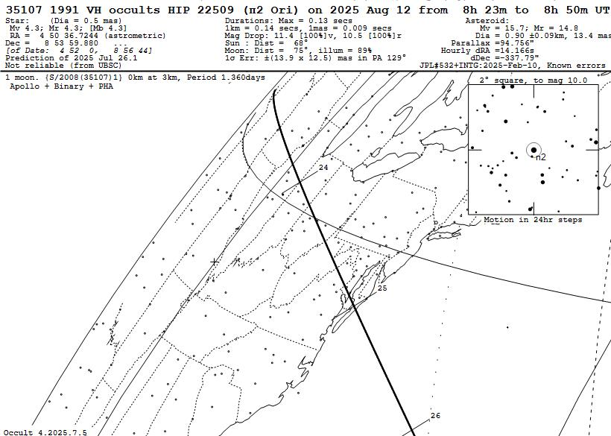

For the rest of the year, we found 7 unique occultations of these visible from or within 20 km of our home in Arizona; with a satellite possibility some distance from the path, that means that an event for one of these could occur, so we should try to observe each of them.

General information, and Occult input files

The orbital elements are all from the NASA JPL Horizons Web site at https://ssd.jpl.nasa.gov/horizons.cgi and the stellar data are from the third release (DR3) of the European Space Agency’s Gaia mission, as implemented with UCAC4, Tycho, and Hipparcos catalog identifiers with IOTA’s free Occult software. Since the orbits are often updated, for any event noted here, you should check to see if there is a more recent and more accurate prediction for the event on Occult Watcher Cloud.

The European Section of IOTA has their own priority events with calls for observations on their Web page at https://call4obs.iota-es.de/ and especially for slow-rotating asteroids at https://www.iota-es.de/neglected_asteroids.html – European observers should consult it, since it includes several events that are not in my lists. I consult it to find some of the asteroids for our selection here.

The maps were produced with IOTA’s free Occult software; see http://www.lunar-occultations.com/iota/occult4.htm . You can download and use this software and use it to compute your own local lists and information about these and many other occultations. The information for doing this is at http://www.lunar-occultations.com/iota/2025iotapredictions.pdf . This describes a prediction input file for planetary and asteroidal files called All2025.xml. You can use that file to generate local predictions, but you can replace it with the expanded special MB Occult input files for the rest of 2025 given on the Web page associated with this document at https://occultations.org/publications/rasc/2025/nam25MBspecialoccs.htm . You can use the files to generate local predictions for more occultations, mainly of fainter stars than shown on our maps above, or for other parts of the world.

For worldwide occultations by major and all types of minor planets (mainly main-belt) worldwide for the whole year, fairly comprehensive only to mag. 12.0 (for N. America) and to mag. 10.5 (for the rest of the world) for asteroids, use the All2025.xml file noted above, but even more occultations can be found with Occult Watcher (it is limited to the next two months); much information for downloading and using it can be found at https://occultations.org/observing/software/ow/ .

David and Joan Dunham, dunham@starpower.net, 2025 July 26

