**Occultations by Major Planets and their Satellites**

The text from the Handbook is repeated below. Following that is the Occult program input file with instructions for using the program to generate your own local predictions for many more occultations, for wherever you are in the world. This Web page concentrates on occultations by the major planets and their satellites, while other pages give similar information, and Occult input files, for occultations by main-belt asteroids, and by other classes of asteroids, including Near-Earth Asteroids (NEA’s), Jupiter Trojan asteroids, and more distant objects, the Centaur asteroids and Kuiper-Belt Objects (KBO’s) or Trans-Neptunian Objects (TNO’s).

_ _ _

**Handbook Text**

As major, dwarf, and minor planets, and their moons, move across the sky, they occasionally pass directly between an observer and a distant star, producing an *occultation*. Astronomers have learned much about solar system bodies by carefully monitoring the changing apparent brightness of stars during the immersion and emersion phases of occultations. If the occulting body does not have an atmosphere, the occultation is virtually instantaneous; if there is an atmosphere, it causes the star’s disappearance and reappearance to occur gradually. If a planet has rings or other debris in its environs, the extent and degree of transparency of this material can be precisely mapped. The rings of Uranus, the ring arcs of Neptune, and the atmosphere of Pluto were all discovered by occultation observations. If an occultation is observed at several distributed sites, the size and shape of the occulting body can be determined more accurately than by other Earth-based techniques.

**2023 Occultations by Major Planets**

Occultations by the major planets are difficult to observe due to the brightness of the occulting body; events involving stars bright enough to observe next to a dazzling planet are rare. Dave Herald supplied the Occult input file for 2023 worldwide predictions of occultations by the major planets and by their main satellites. The only major planet event that might be observed from North America will be an occultation for up to 25 minutes by Venus of 7.4-mag. SAO 98451 = HIP 45363, spectral type K2, around 7:30 U.T. of September 22nd, visible from the Atlantic Provinces, but practically only from Newfoundland and eastern Nova Scotia; Venus will be less than 7° high farther west. Bermuda is closer to the central line, probably not enough to see a central flash, but the altitude will be only 5° when the star reappears. Only the reappearance on the dark side, far from V With Venus’ magnitude of -4.8, the bright side disappearance can not be observed, but the star might be observed when it reappears on the dark side of Venus’ disk, 36ʺ in diameter and 30% sunlit. Predictions for contact times and circumstances **will be posted** **in March** on a page about the event at [**https://occultations.org/publications/rasc/2023/20230922Venus.htm**](https://occultations.org/publications/rasc/2023/20230922Venus.htm) **.** The Occult map for the event is at the top of the next page.

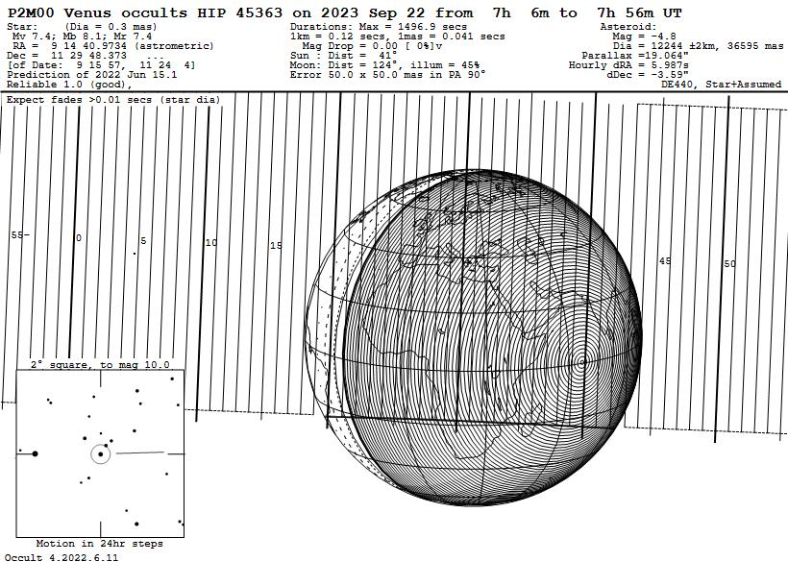

The brightest star occulted by any planet in the world over land in 2023 will be 6.7-mag. ZC 1828 = SAO 138942 = HIP 62141 by Venus on Nov. 18 from W. Australia; see the Occult map below.

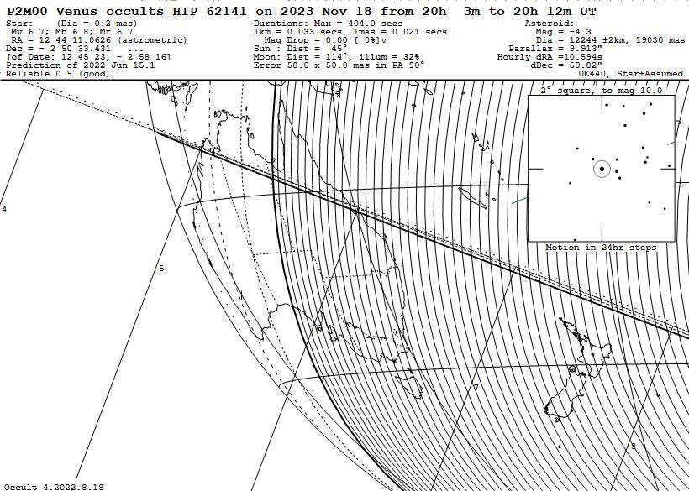

**2023 Occultations by Satellites of Major Planets**

Easier to observe are occultations by moons of the planets, but they are not common. The best during 2023 will be an occultation of an 11.8-mag. star by Uranus’s large moon Titania visible from much of North America around 5:18 UT of November 21st for up to 73 seconds. 14th-mag. Titania will be about 20ʺ east-southeast of Uranus. Its Occult map is on the top of the next page.

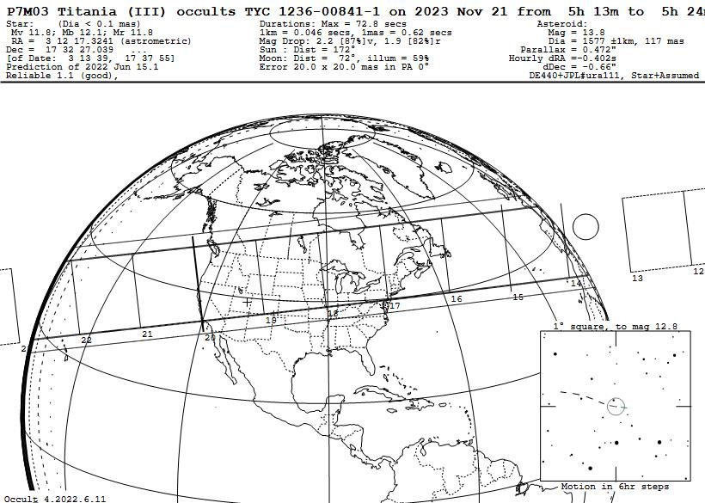

Also noteworthy is an occultation by Titan in western North America on Nov. 25 UT (Nov. 24th evening local time) but the star is faint, needing very large telescopes to observe with a methane-band filter. The Occult map is below.

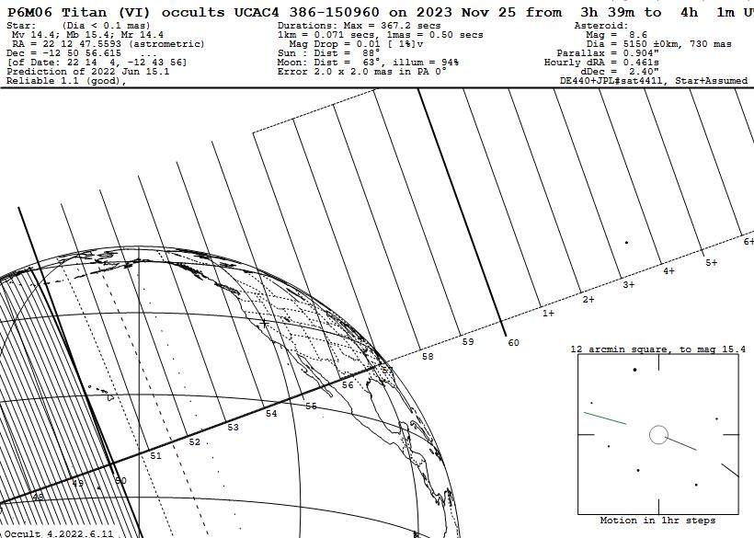

Occultations by the irregular outer moons of Jupiter are predicted by astronomers working for the Lucky Star project, but usually only a few weeks in advance, based on special astrometric updates; IOTA’s Occult program found no such events by the larger ones during 2023.

The maps given at the end of this document, and on previous pages, were produced with IOTA’s free Occult software; see [**http://www.lunar-occultations.com/iota/occult4.htm**](http://www.lunar-occultations.com/iota/occult4.htm). The orbital elements are all from the NASA JPL Horizons Web site at [**https://ssd.jpl.nasa.gov/horizons.cgi**](https://ssd.jpl.nasa.gov/horizons.cgi) and the stellar data are from the Early third release (EDR3) of the European Space Agency’s Gaia mission, as implemented with UCAC4, Tycho, and Hipparcos catalog identifiers with *Occult*.

Note that the times are for the geocentric time of closest approach; for any specific location in North America, the event time can be several minutes earlier or later.

You can download and use IOTA’s free Occult program and use it to compute your own local lists and information about these and many other occultations. The information for doing this is at

[http://www.lunar-occultations.com/iota/2023iotapredictions.pdf](http://www.lunar-occultations.com/iota/2022iotapredictions.pdf) . This describes a prediction input file for planetary and asteroidal files called **All2023.xml**. Besides the occultations by major planets and their main moons, it also includes all of the occultations, generally down to about 12th magnitude, found by Edwin Goffin and Steve Preston, and some other IOTA members working with them. You can use that file to generate local predictions, but you can replace it with the other files listed below and on the pages for other types of occultations:

**Planets2023.xml** – This is the input for 237 occultations of stars by the major planets, including Pluto, and by Jupiter’s Galilean Satellites, and by the major satellites of Saturn and Uranus. Included are several unobservable occultations of very faint stars, especially by the Galilean satellites; a few of those can be observed if the satellite is in total eclipse by Jupiter’s shadow; in that case, Occult detects that fact, and replaces the magnitude of the satellite with 16.0, to calculate a more realistic magnitude drop for the situation. Not included, as has been the case for some previous years, are occultations by the Martian satellites Phobos and Deimos, and by the satellites of Neptune and Pluto; predictions for them are given by Occult Watcher, if you select its feed for occultations by planetary satellites. A list of all of these events is at [**https://occultations.org/publications/rasc/2023/PlanetsPlusMainSatellites2023.txt**](https://occultations.org/publications/rasc/2023/PlanetsPlusMainSatellites2023.txt) **.**

For worldwide occultations for the whole year, use the **All2002.xml** file noted above, but even more occultations can be found with Occult Watcher (it is also limited to the next two months); links to it are given above.

**Links to other 2023 RASC asteroidal occultation pages**

First versions of the below pages will be posted later this week, except for the distant objects, which will follow a week or two later (in the meantime, for them, consult the Lucky Star prediction page at

[**https://occultations.org/publications/rasc/2023/nam23NEAoccs.htm**](https://occultations.org/publications/rasc/2022/nam22NEAoccs.htm)- Occultations by Near-Earth Asteroids (NEA’s)

[**https://occultations.org/publications/rasc/2023/nam23MBspecialoccs.htm**](https://occultations.org/publications/rasc/2022/nam22MBspecialoccs.htm)- Occultations by some special main-belt objects

[**https://occultations.org/publications/rasc/2023/nam23Trojanoccs.htm**](https://occultations.org/publications/rasc/2022/nam22Trojanoccs.htm)- Occultations by Trojan asteroids

[**https://occultations.org/publications/rasc/2023/nam23distantoccs.htm**](https://occultations.org/publications/rasc/2022/nam22distantoccs.htm)- Occultations by more distant objects

[**https://occultations.org/publications/rasc/2023/OccultWatcher.htm**](https://occultations.org/publications/rasc/2022/OccultWatcher.htm)- Occult Watcher information

Below are Occult maps for occultations of fainter stars, requiring largish telescopes to record, by two satellites of Saturn and one by Miranda, the inner and fainter of the five main moons of Uranus.

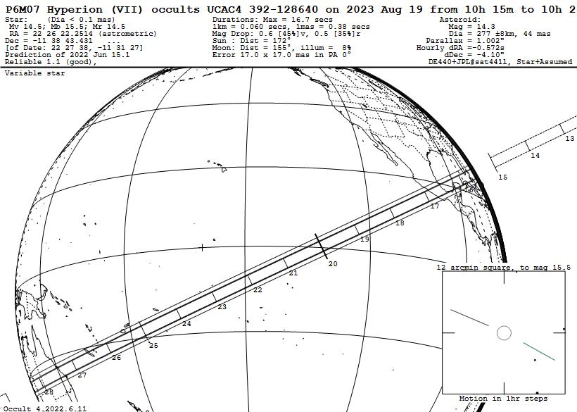

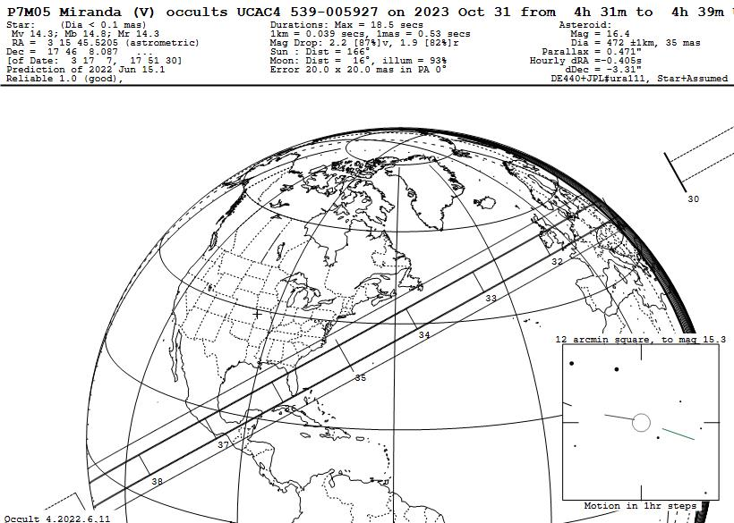

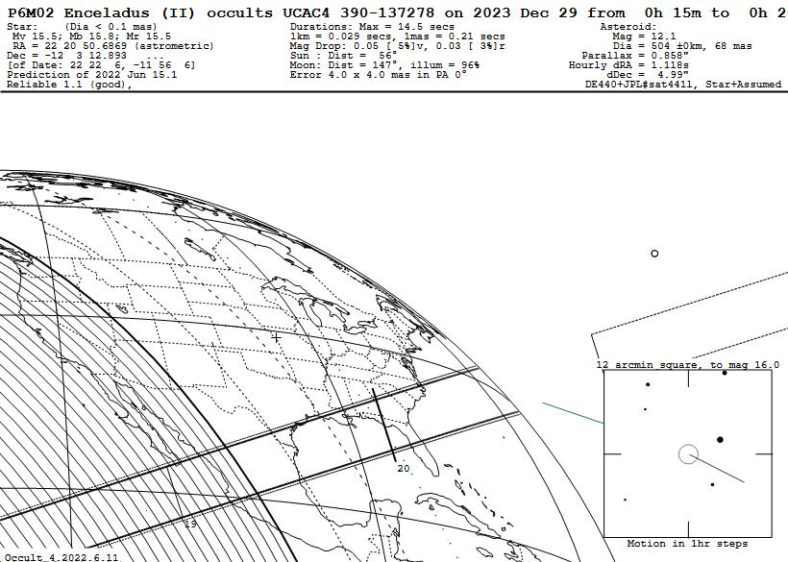

David Dunham, [dunham@starpower.net](mailto:dunham@starpower.net), 2022 January 5